Experiment Name
Configuration and Packet Transmission Using OSPF Protocol for Inter-Network Communication
Objectives
The purpose of this experiment is to design and implement a multi-router network using Cisco Packet Tracer and to study the behavior of the OSPF (Open Shortest Path First) routing protocol. This experiment aims to demonstrate how OSPF enables dynamic routing, automatic route discovery, and efficient communication between different networks. It also focuses on verifying OSPF neighbor relationships and ensuring successful packet delivery across multiple LANs.
System Configuration
Software Used:
Cisco Packet Tracer (Version 8.x or above)
Operating System:
Windows 10 / Windows 11
Network Devices:
- Three Cisco 1841 Routers
- Three Cisco 2960 Switches
- Six Personal Computers (two PCs per LAN)
Cables Used:
- Copper Straight-Through cable (PC to Switch)
- Copper Cross-Over cable (Switch to Router and Router to Router)
Routing Method:
Dynamic Routing using OSPF Protocol
Steps and Procedures
Step 1: Setting Devices on Cisco Packet Tracer Workspace
At first, all required networking devices were placed on the Cisco Packet Tracer workspace. Three routers, three switches, and six PCs were selected from the device panel and arranged logically to represent different networks. Proper naming was assigned to each device to make identification easier during configuration.
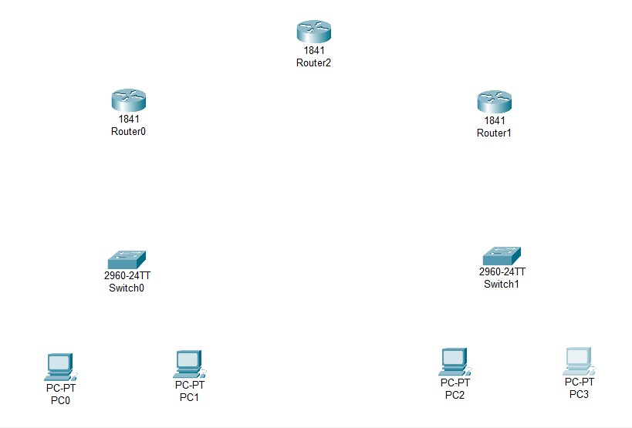
Figure 8.1: Placing all of the devices to workspace
Step 2: Creating the Network Topology
After placing the devices, the routers were interconnected in a linear topology where Router0 was connected to Router2, and Router2 was connected to Router1. Each edge router was connected to a switch, and each switch was connected to two PCs, forming two separate LANs. Network A was connected to Router0, while Network B was connected to Router1.
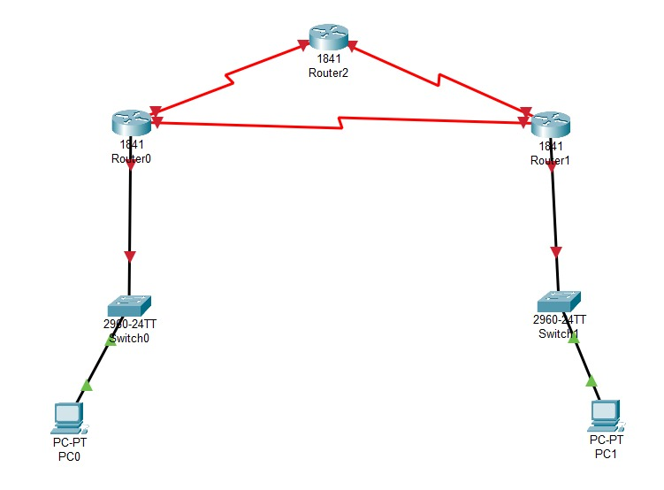
Figure 8.2: Connecting wires to create topology
Step 3: Assigning IP Addresses to PCs
IP addresses were manually assigned to all end devices according to their respective networks.
PC IP Address––––––––––Subnet Mask–––––––Gateway
PC0 192.168.1.2 – 255.255.255.0 – 192.168.1.1
PC1 192.168.2.2 – 255.255.255.0 – 192.168.2.1
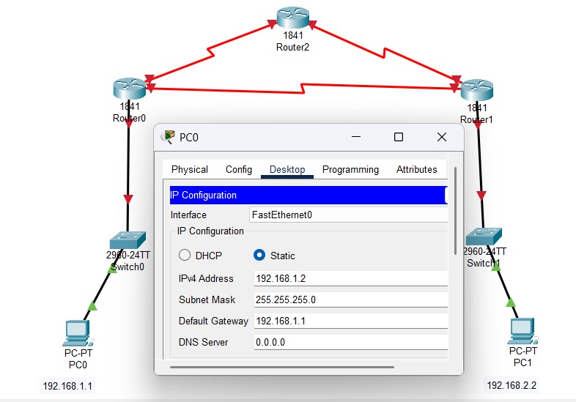
Figure 8.3: Configuring IP Addresses to all PCs

Step 4: Configuring OSPF on Routers
The OSPF routing protocol was configured on all three routers. Each router was assigned to the same OSPF process ID, and all connected networks were advertised using appropriate network commands. This allowed routers to exchange routing information dynamically and build their routing tables automatically.
For Router0
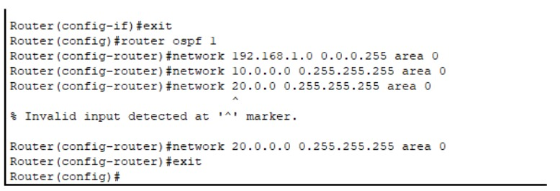
Figure 8.4: Configuring OSPF For Router0
For Router1
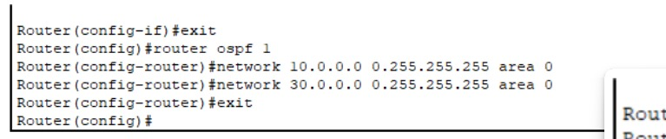
Figure 8.5: Configuring OSPF For Router1
For Router2

Figure 8.6: Configuring OSPF For Router2

Step 5: Verifying OSPF Neighbor Relationships
After configuration, verification commands were executed on each router to confirm successful OSPF operation. The show ip ospf neighbor command was used to check whether routers had formed neighbor adjacencies, and the show ip route ospf command was used to confirm that OSPF-learned routes were present in the routing table.
Step 6: Simulation and Connectivity Testing
Finally, network simulation was performed using the ping command. ICMP packets were sent from one PC in Network A to another PC in Network B. Successful replies confirmed that OSPF routing was functioning correctly and that packets could traverse multiple routers dynamically.
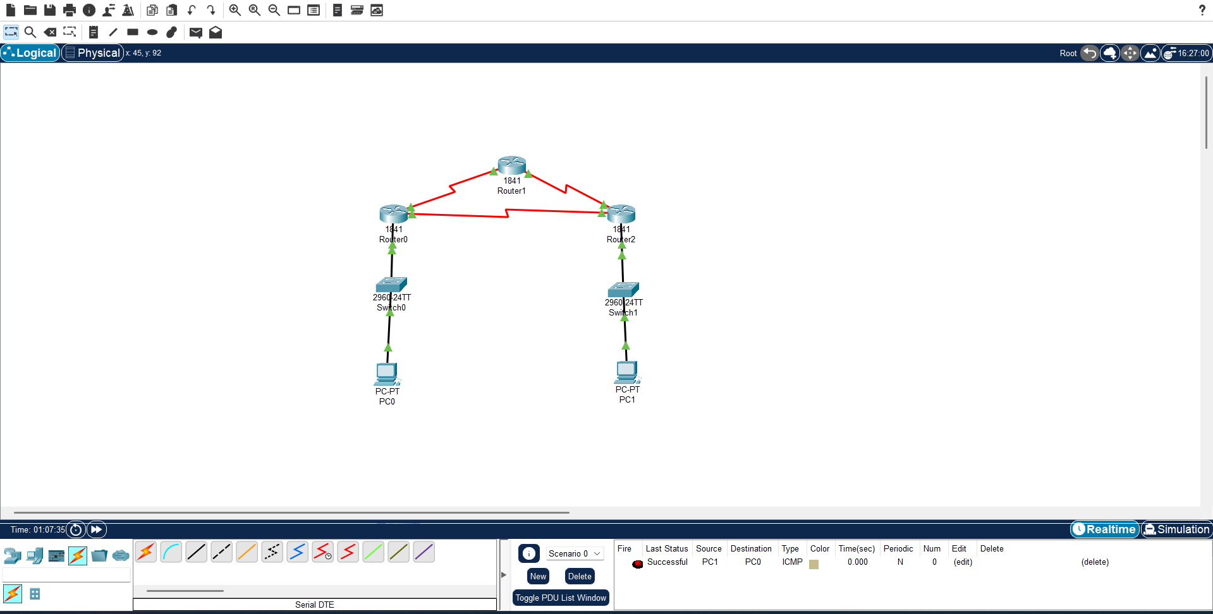
Figure 8.7: Vefirying The Connectivity Using Simulation
Result and Discussion
The experiment successfully demonstrated the implementation of OSPF dynamic routing across multiple routers. All routers formed neighbor relationships automatically and exchanged routing information without manual route configuration. The routing tables were updated dynamically, and end-to-end communication between different networks was achieved. The results confirmed that OSPF efficiently selects optimal paths and adapts automatically to network topology changes.
Conclusion
In this experiment, the OSPF routing protocol was implemented to establish communication between different networks using multiple routers. The routers successfully discovered each other, exchanged routing information, and enabled reliable packet transmission between distant LANs. The experiment highlights the advantages of OSPF over static routing, including scalability, faster convergence, and reduced administrative effort, making it suitable for medium to large-scale networks.

